LAB ASSIGNMENT -END
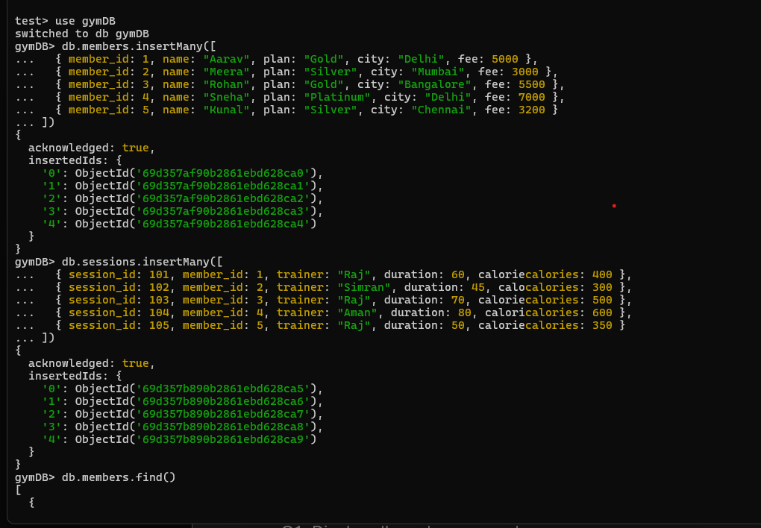
DATE: 06/04/2026
member_id |  |  | name | plan |  | city | fee
1 | Aarav | Gold |  |  | Delhi |  |  | 5000
2 | Meera | Silver |  |  | Mumbai |  |  | 3000
3 | Rohan | Gold |  |  | Bangalore |  |  | 5500
4 | Sneha | Platinum |  |  | Delhi |  |  | 7000
5 | Kunal | Silver |  |  | Chennai |  |  | 3200

session_id | member_id | trainer | duration | calories
101 | 1 | Raj | 60 | 400
102 | 2 | Simran | 45 | 300
103 | 3 | Raj | 70 | 500
104 | 4 | Aman | 80 | 600
105 | 5 | Raj | 50 | 350


QUESTIONS
Q1. Display all members
Q2. Show name and plan only
Q3. Find members from Delhi
Q4. Find sessions with duration > 60
Q5. Sort members by fee descending
Q6. Update fee +500 for Gold members
Q7. Delete members with fee < 3500
Q8. Insert a new member
Q9. Average fee per plan
Q10. Total calories burned per trainer
Q11. Maximum fee per city
Q12. Count members per plan
Q13. Trainers with avg calories > 400
Q14. Total duration per member_id
Q15. Join members with sessions
Q16. Show members who have sessions
Q17. Create index on city
Q19. Create compound index on plan and fee
Q20. Display 2nd and 3rd highest fee members

LAB QUESTIONS:

Q1. Display all members

Q2. Show name and plan only.

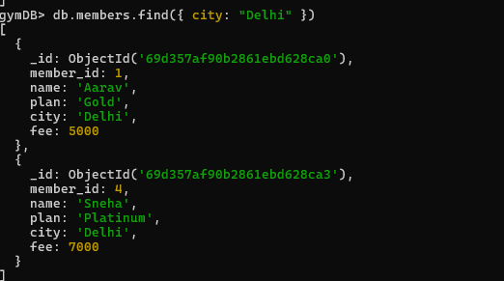
Q3. Members from Delhi.

Q4. Sessions with duration > 60.
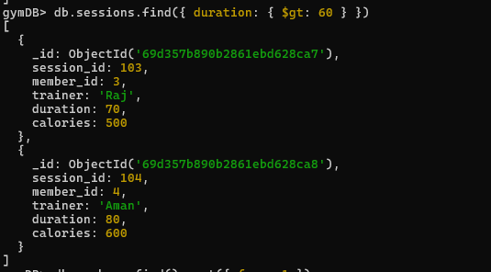
Q5. Sort members by fee descending.
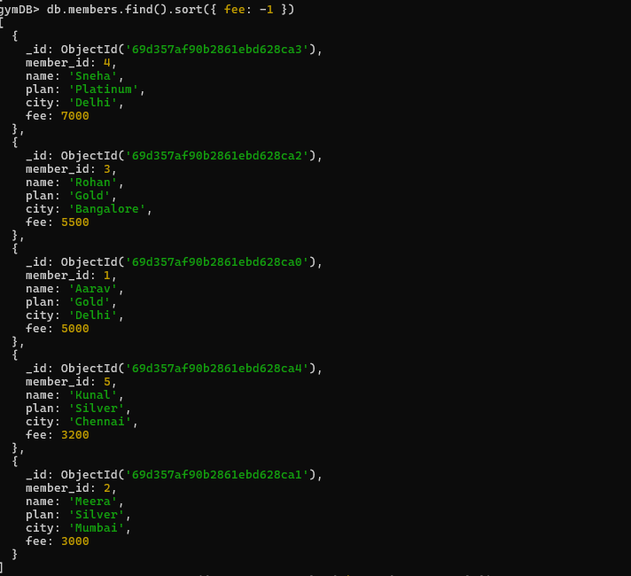

Q6. Update fee +500 for Gold members
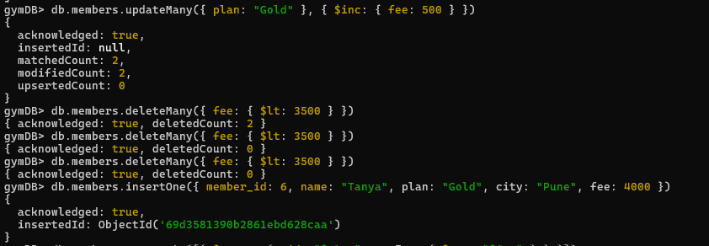
Q7. Delete members with fee < 3500.

Q8. Insert a new member.
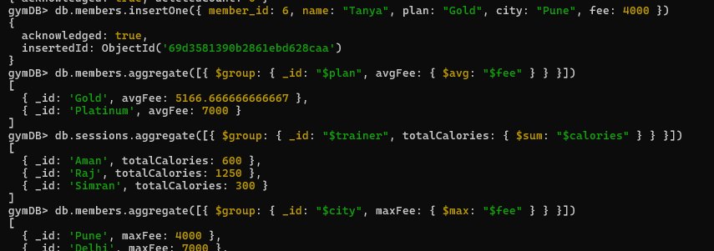

Q9. Average fee per plan.

Q10. Total calories per trainer.
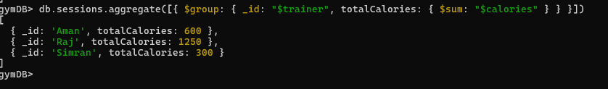
Q11. Maximum fee per city.
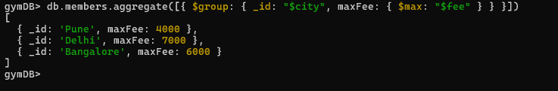

Q12. Count members per plan.
Q13. Trainers with avg calories > 400.
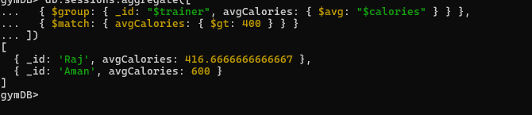
Q14. Total duration per member_id.
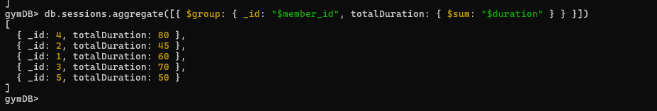
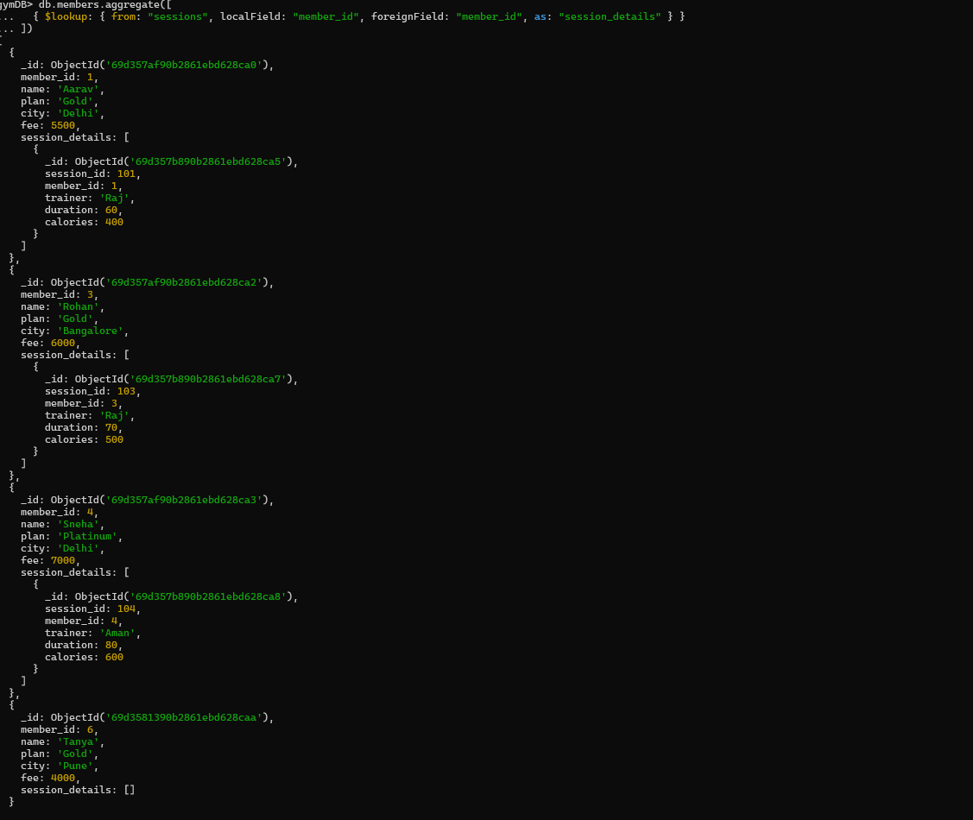
Q15. Join members with sessions.
Q16. Members who have sessions.

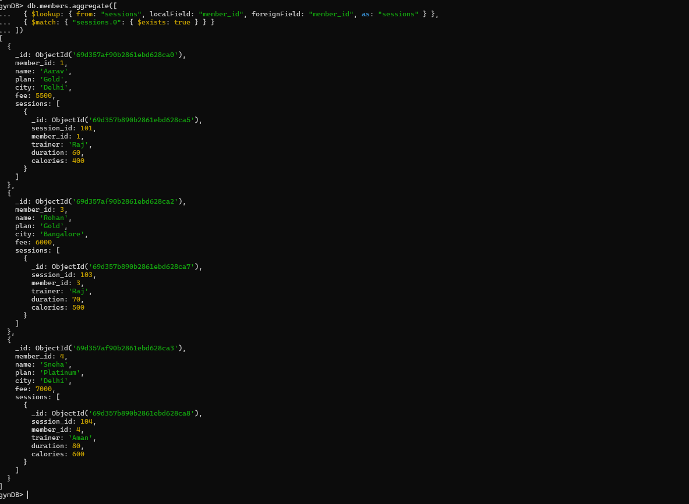
Q17. Create index on city.

Q19. Create compound index on plan and fee.

Q20. 2nd and 3rd highest fee members.
